**What is hibernate?**

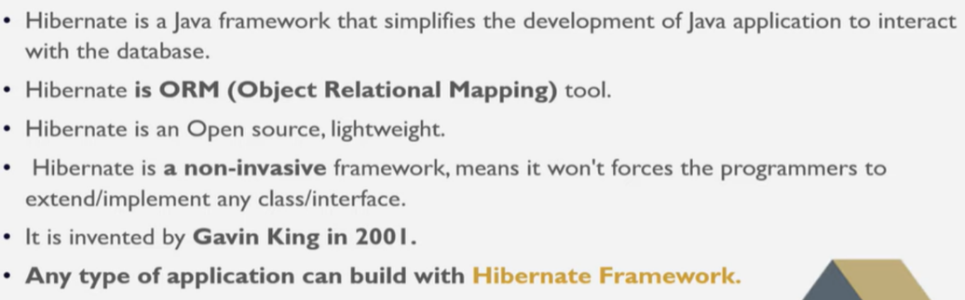

**What are advantages of hibernate?**

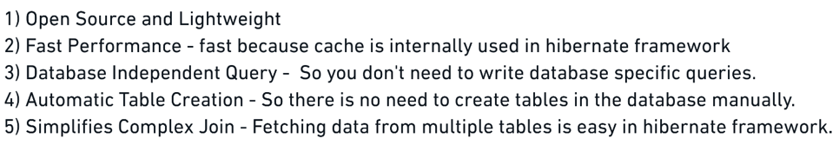

**Why we using hibernate?**

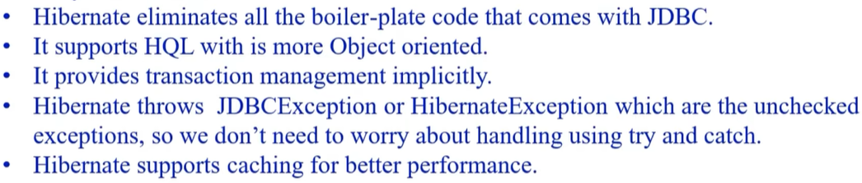

**What are steps use in hibernate?**

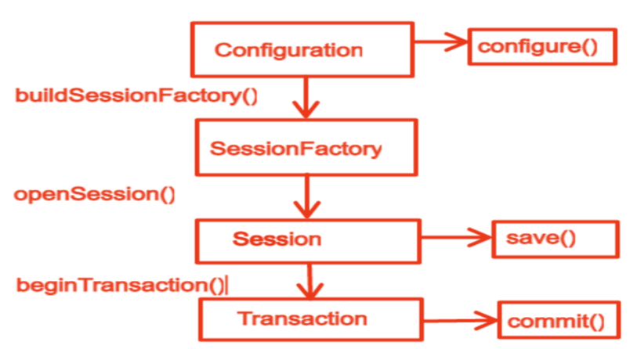

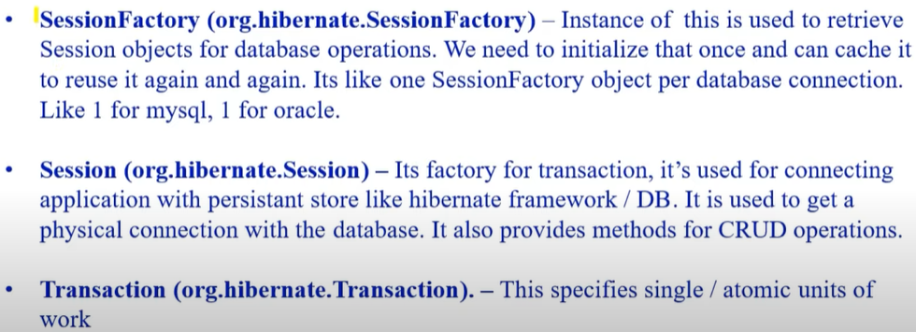

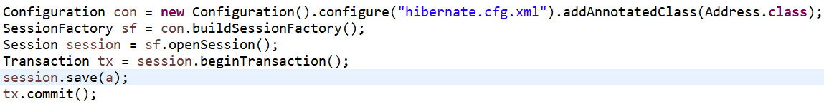

**What are the annotations in hibernate?**

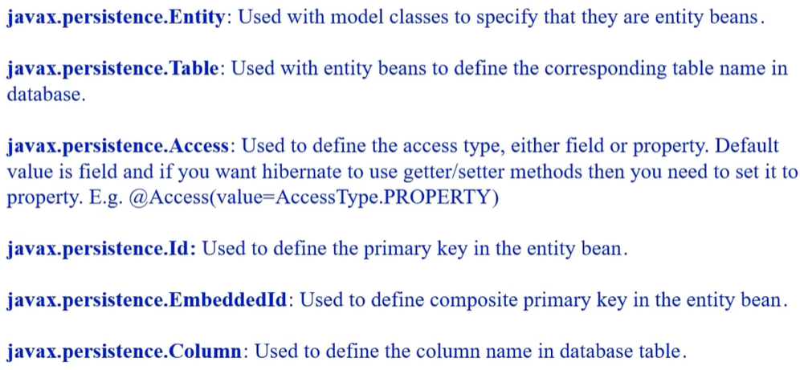

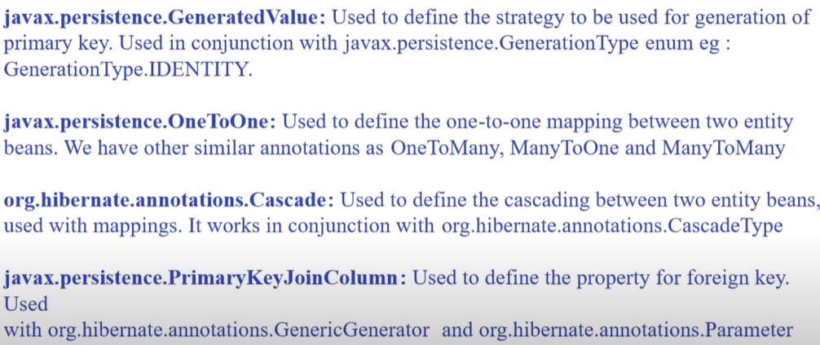

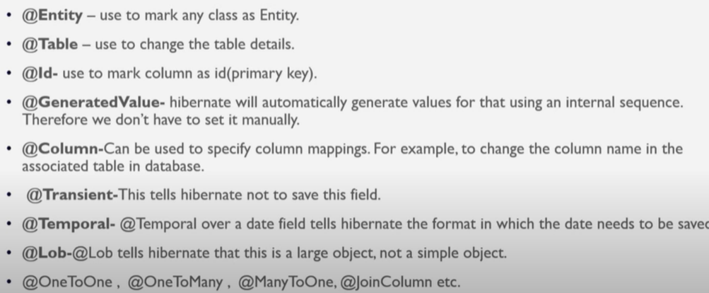

**What are the data loading strategies?**



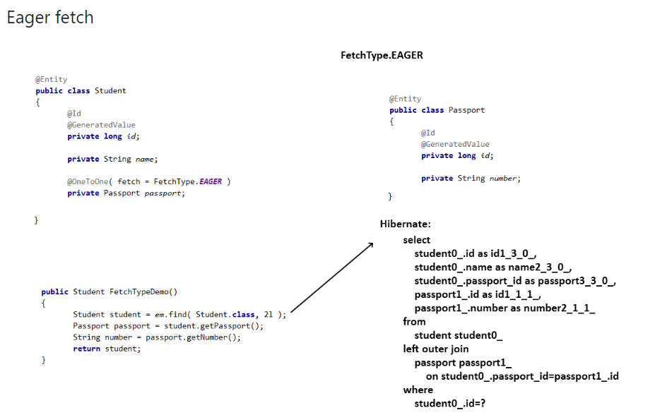

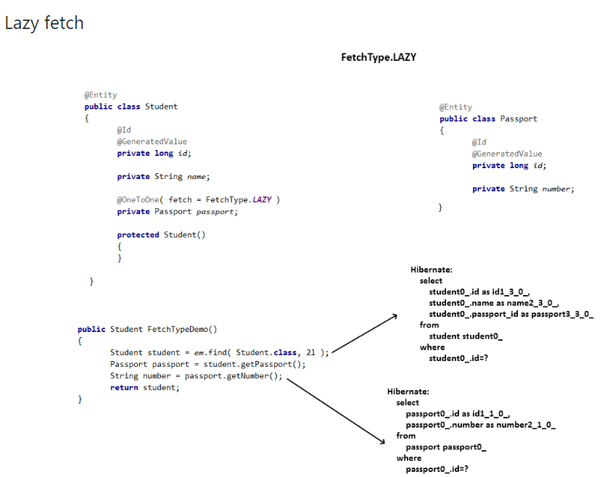

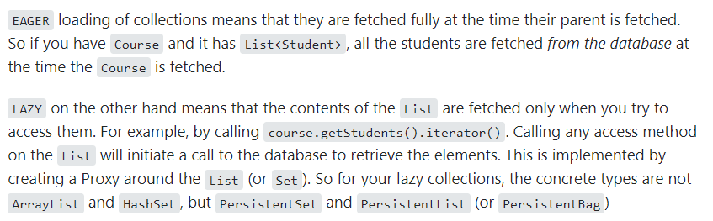

**Differences of Mapped by & join column in hibernate?**

Mapped By – we will apply mapped by on field which ever we don’t to be include in current class table.

Let’s in Patient class we have Docter field from other class then patient table don’t want to add this docter column in table that time we have to used.



Join Column – we will apply this is when we want add one of column from other class in current class like patient id we need to add then we can use join column



**How one to one mapping works in hibernate?**

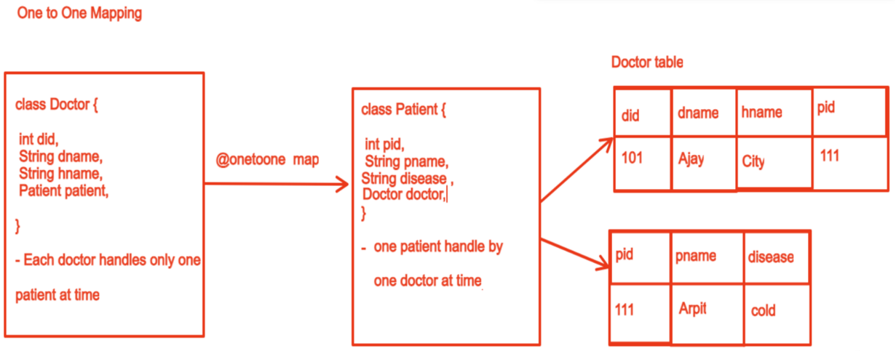

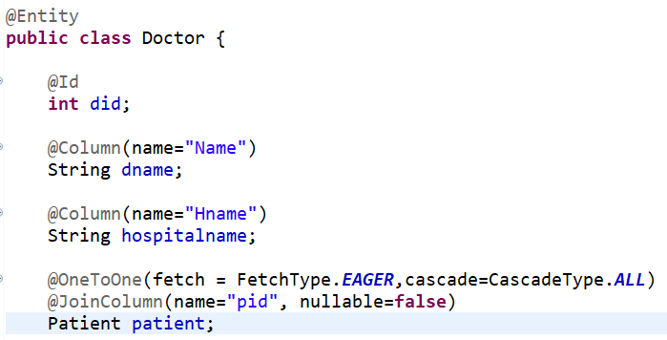 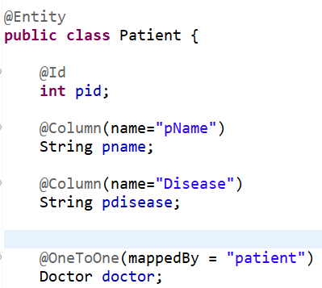 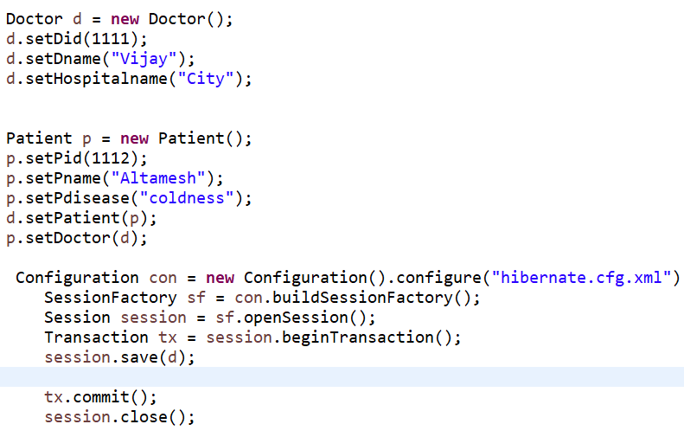

**How one to many & many to one mapping works in hibernate?**

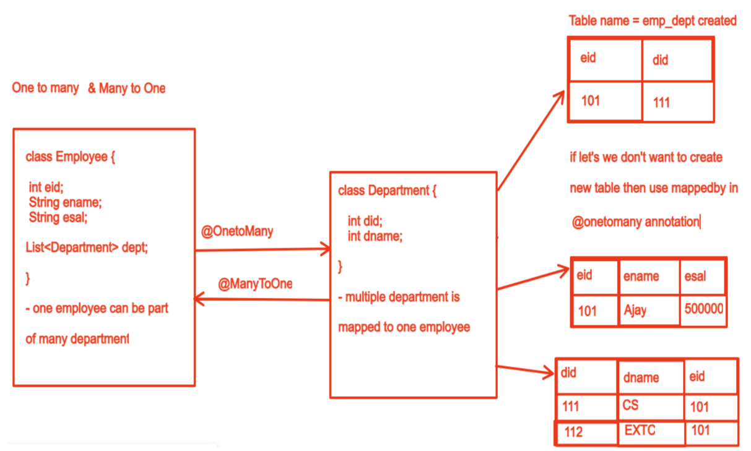

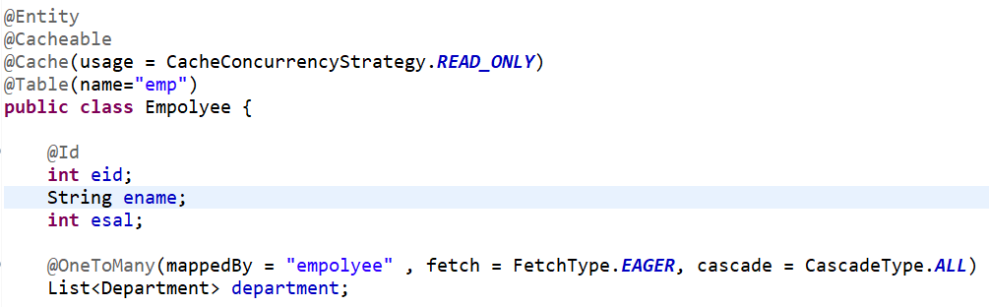 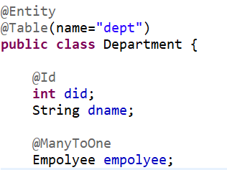 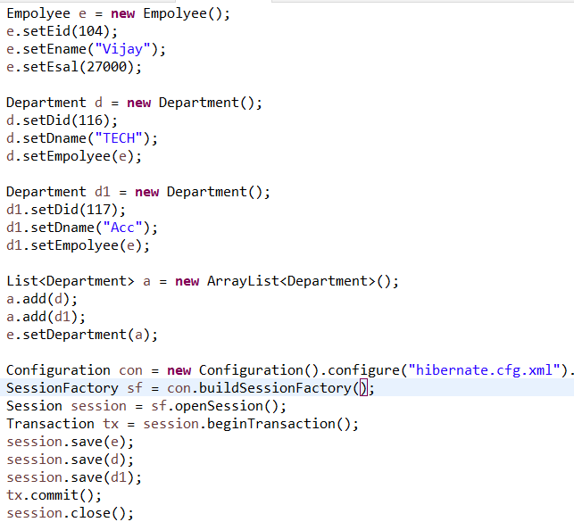

**How many to many mapping works in hibernate?**

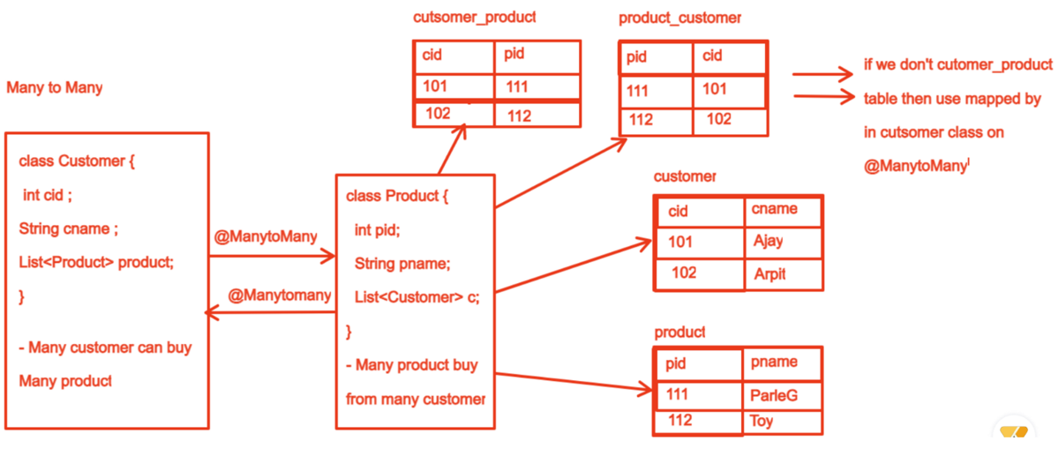

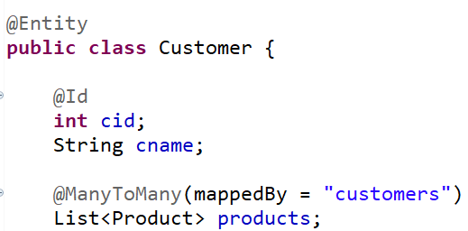 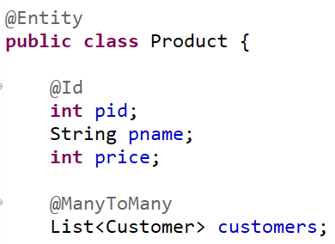 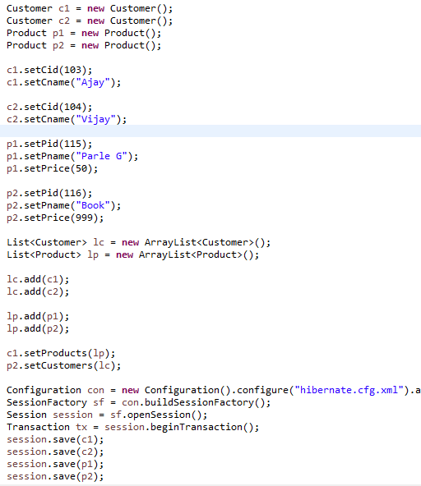

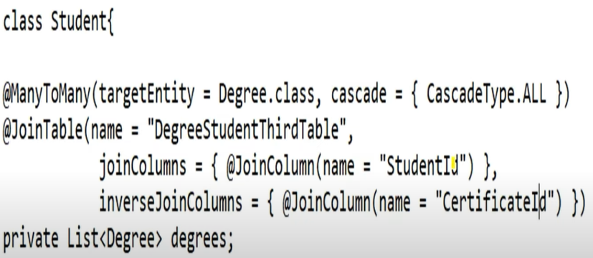

This is another way to implement many to many like join table means here create third table which will have primary key of student table by join column and primary key of degree by inverse join column.

**What are steps to implement hibernate?**

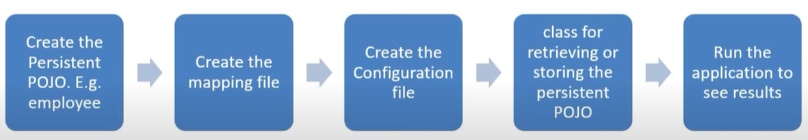

**How hibernate.xml file look ?**

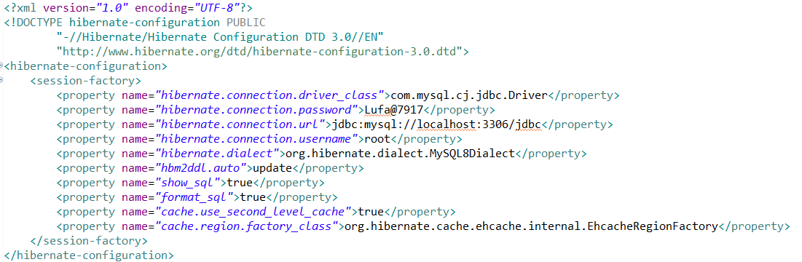

**By xml :**



**By annotation:**



**What are differences of get current session & open session?**

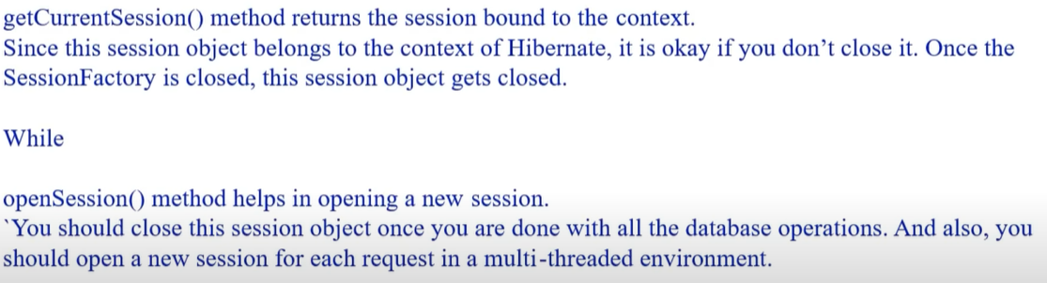

-If you want use get current session in hibernate you need to configure :

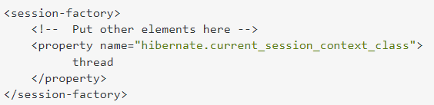

But for open session you need not to configure anything.

Open session is slower and other is fast.

**What are differences of get & load?**

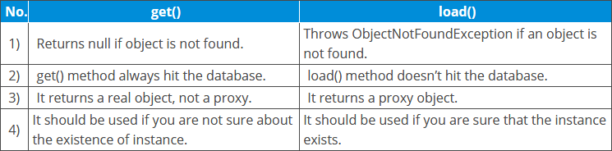

**What are differences of embeddable & embedded?**

**Embeddable is annotation use to join all columns of your class which has this annotation.**

**Embedded – it is apply on field of class that you want to embedded**

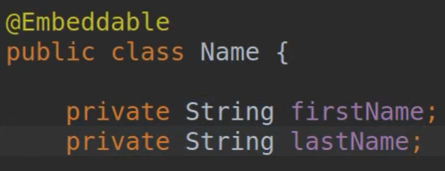 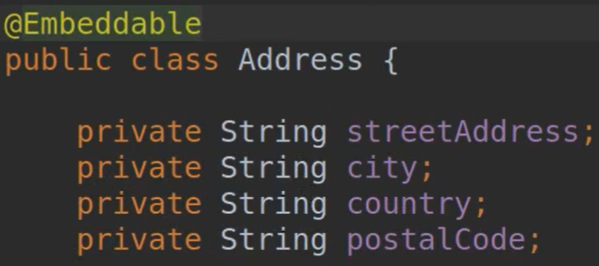 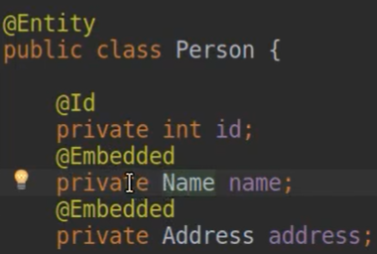

**Person table contains name table all column and address table all column.**

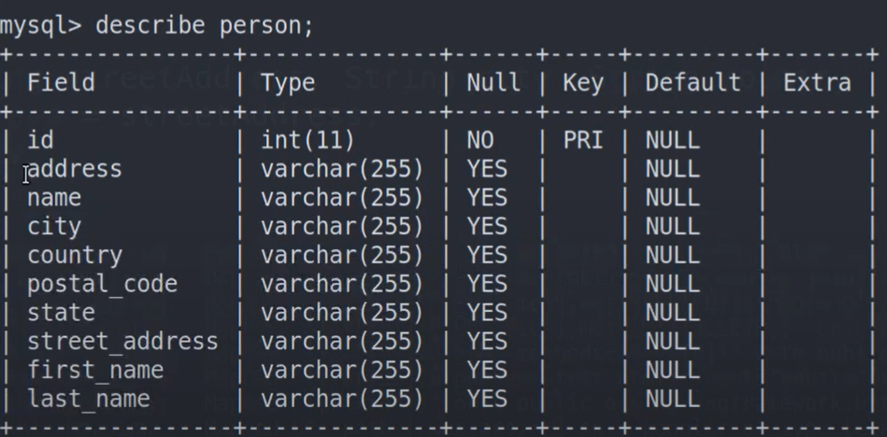

**What are the types of cache and how it works?**

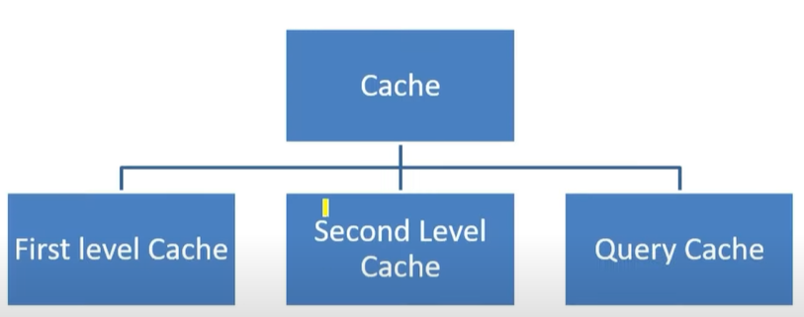

**Advantage :**

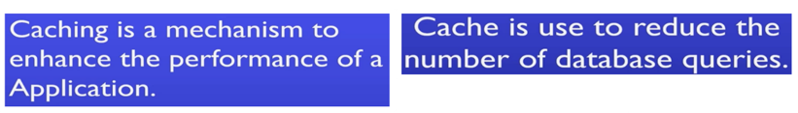

**First Level Cache:**

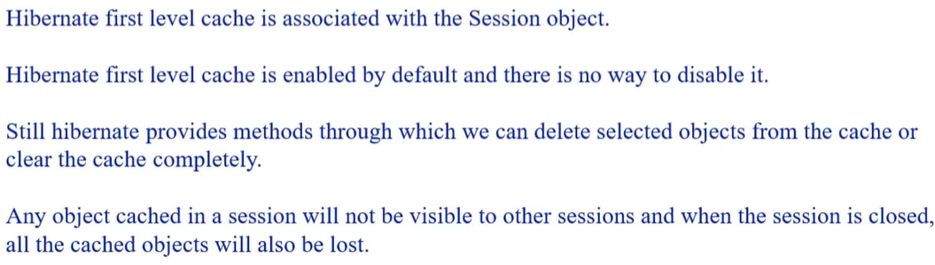

**Second level cache:**

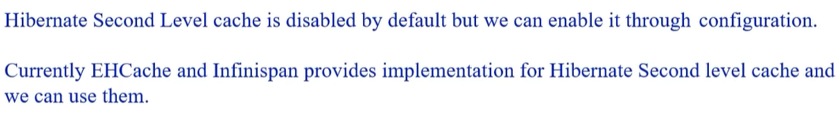

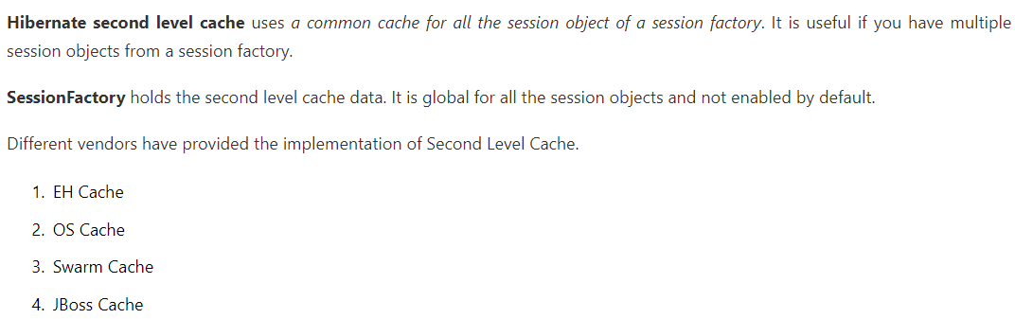

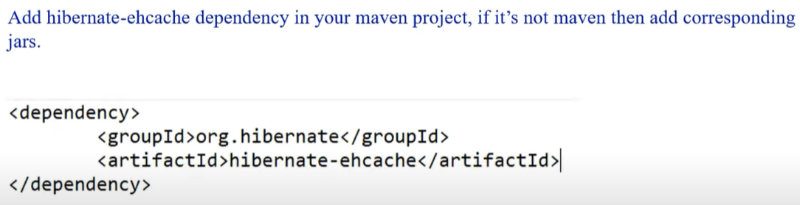



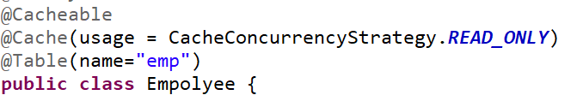

**How to create Eh-cache config file?**

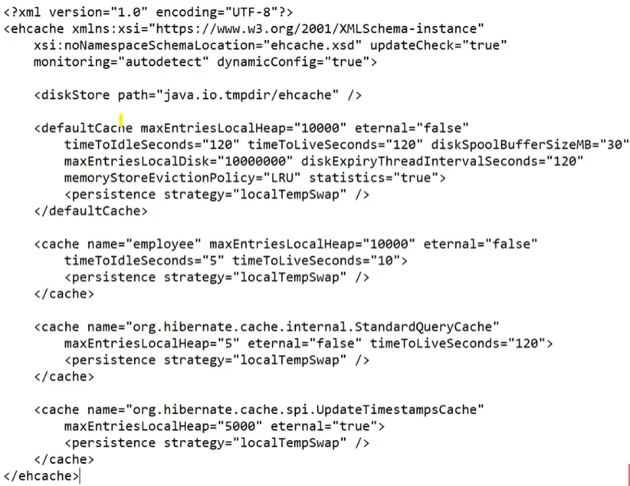

Default cache, region, standard query cache, update time stamp cache. Disk store.

**What are differences of @Cache & @Cacheable**

* Cache is useful when you try to use cache for particular class and set region and usage as cache concurrent cache is read only like this.
* Cacheable means this current class using cache kind of things.

**How you integrate hibernate & spring?**

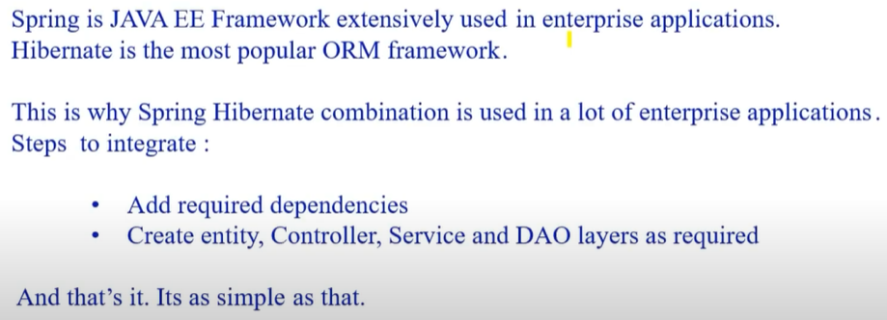

**What is HQL & Need?**

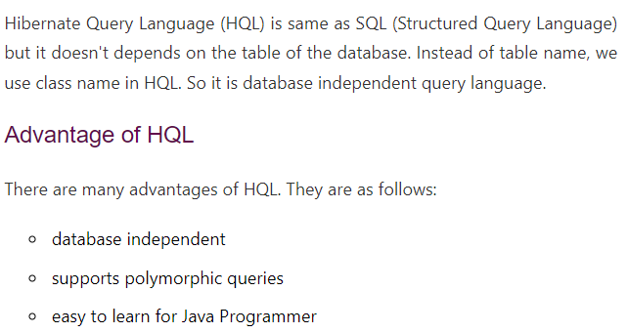

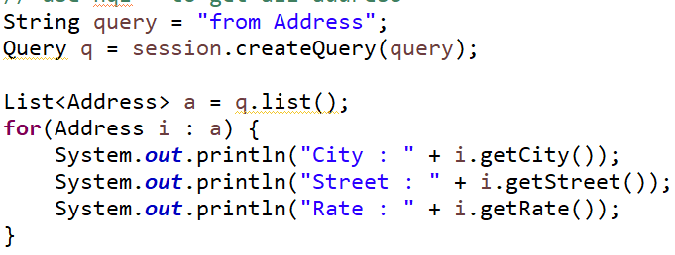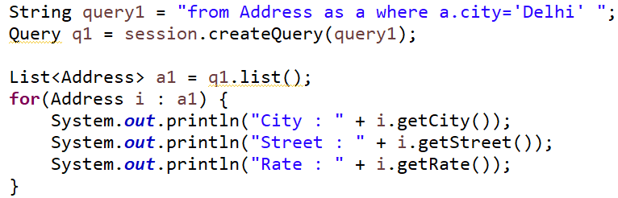

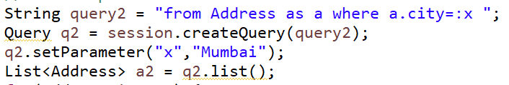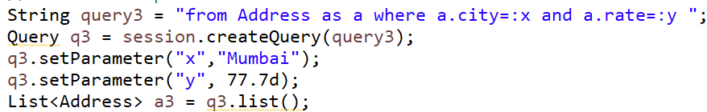

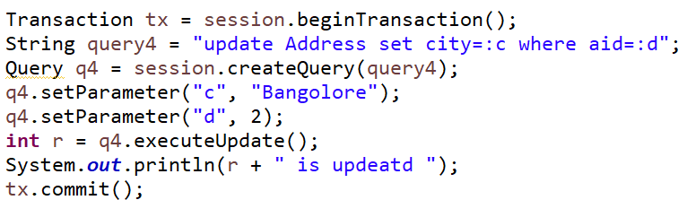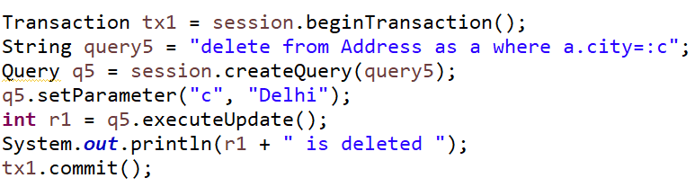

**What is lifecycle of hibernate?**

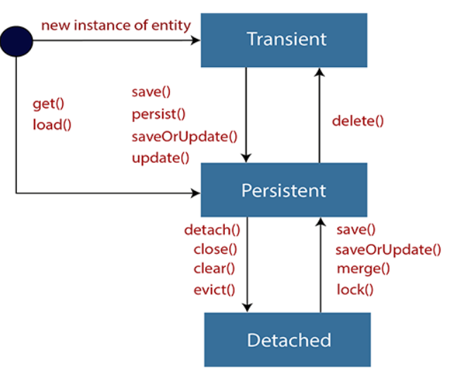

Transient state: POJO instances in transient state, no session, no data base, modify data will not affect to DB

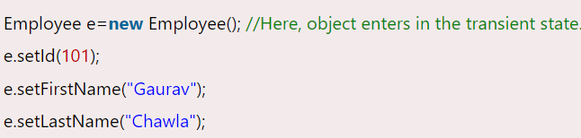

Persistent state: POJO instances with session and with DB, modify will be affect to DB, every row means each object.

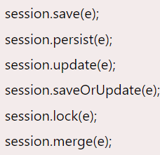

Detached state : clear cache, close conn – detached state, no session, no DB, no modify affect to DB, object representation is still in DB, if you want to persist again use save, merge, save or update, lock..

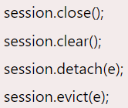

**What are differences of JPA and Hibernate?**

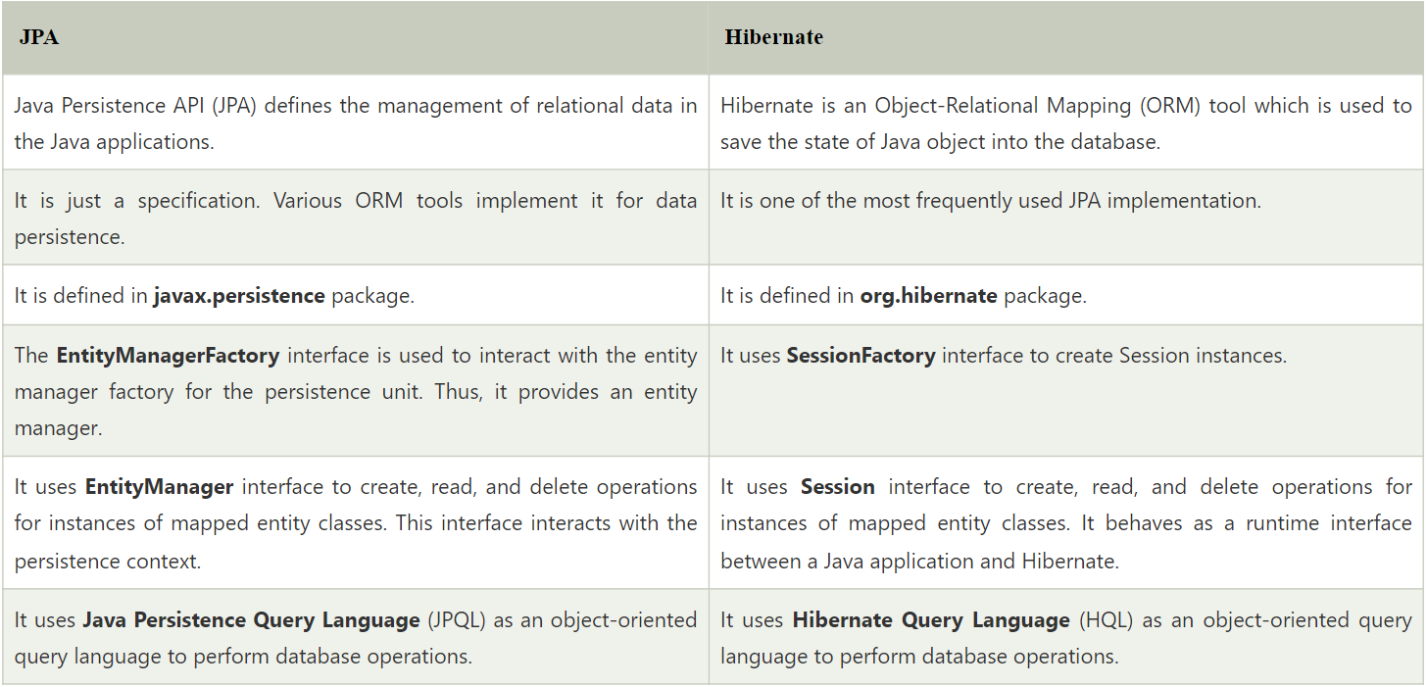

**What is need of JPA?**

